**Project Report**

A COMPREHENSIVE ANALYSIS OF VIDEO GAME SALES

1. **INTRODUCTION** 
   1. **Overview**

Video game sales analysis is the process of collecting and analyzing data about the sales of video games in order to understand market trends and consumer behavior.

* 1. **Purpose**

This type of analysis can be useful for a variety of purposes, including identifying the most popular games and genres, predicting future sales, and developing marketing strategies.

**2**. **Problem Definition & Design Thinking**

**2.1 Empathy Map**

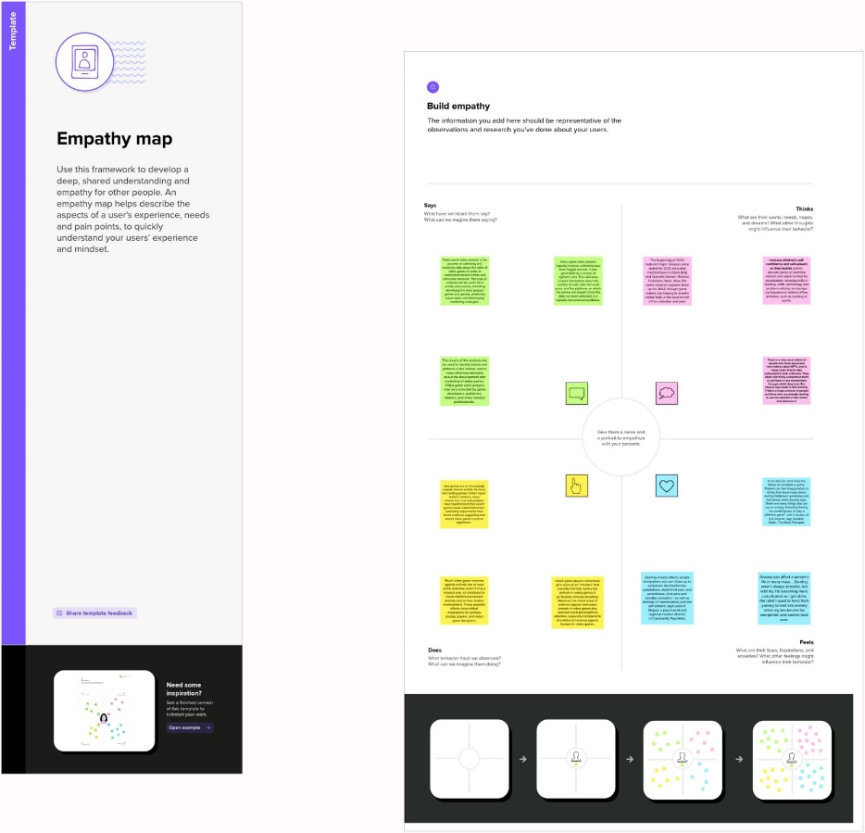

* 1. **Ideation & Brainstorming Map**

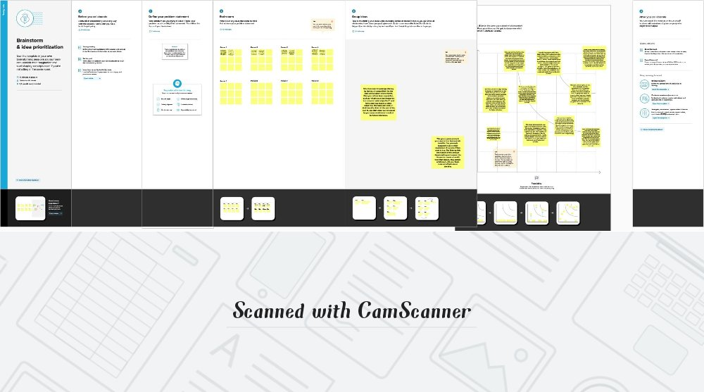

**3. RESULT**

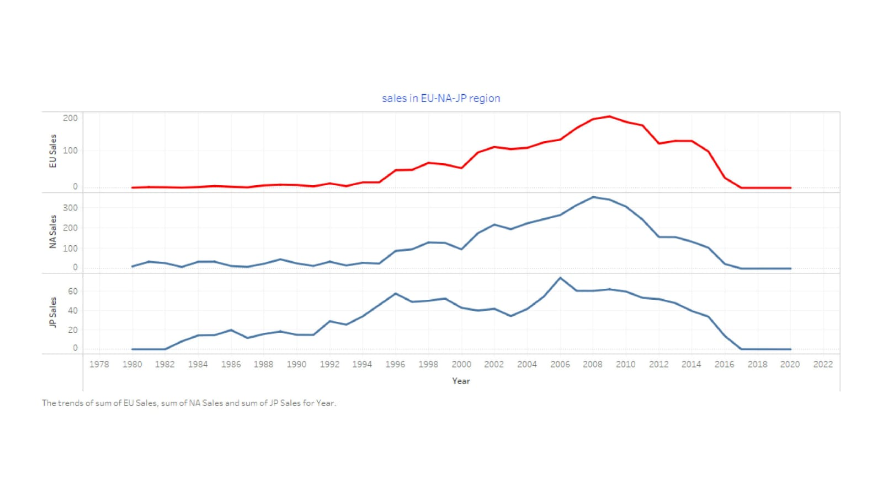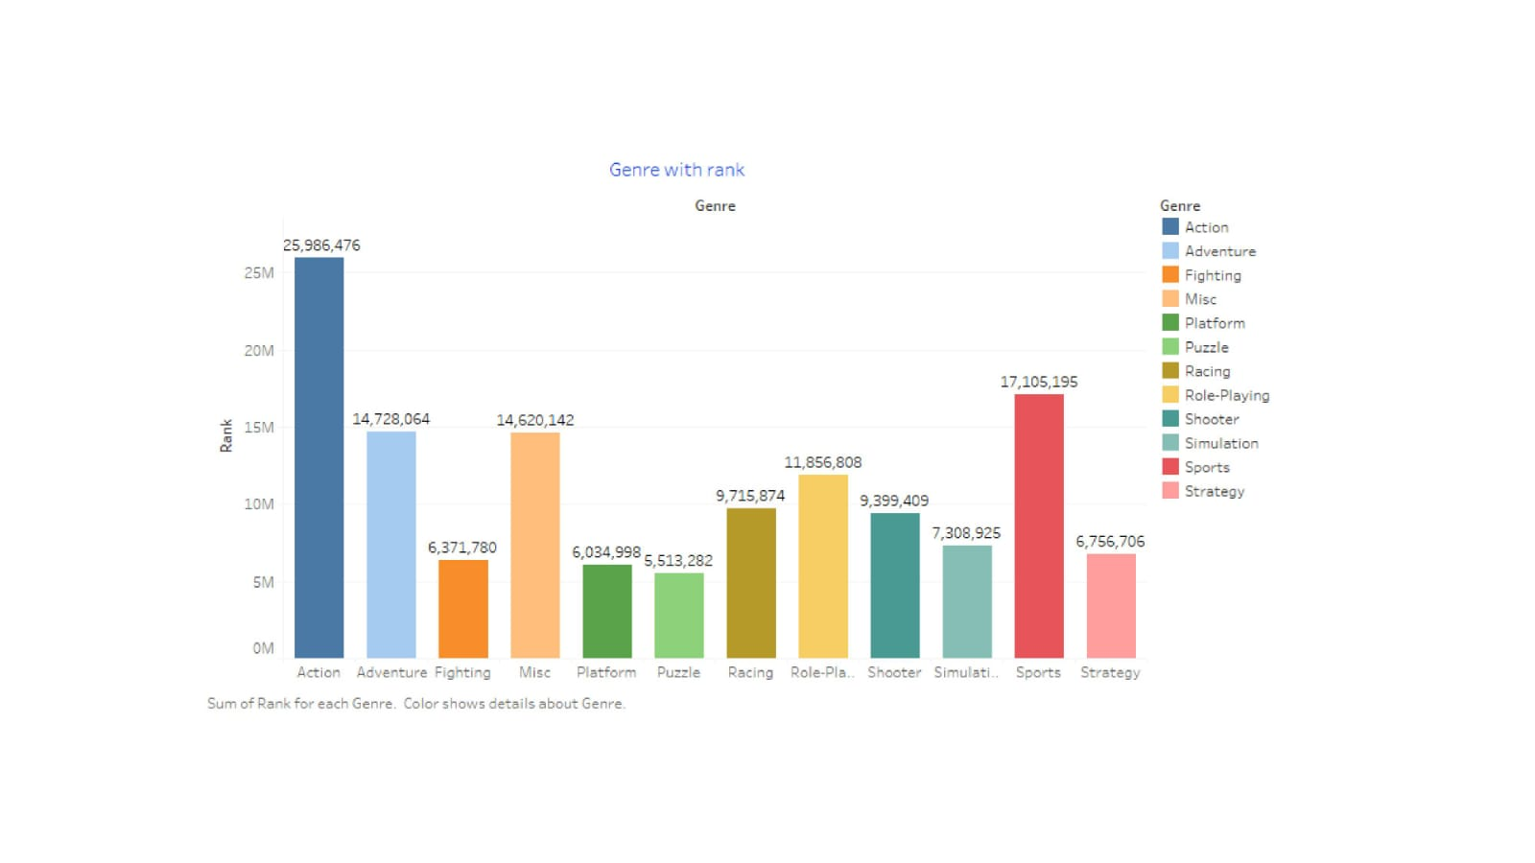

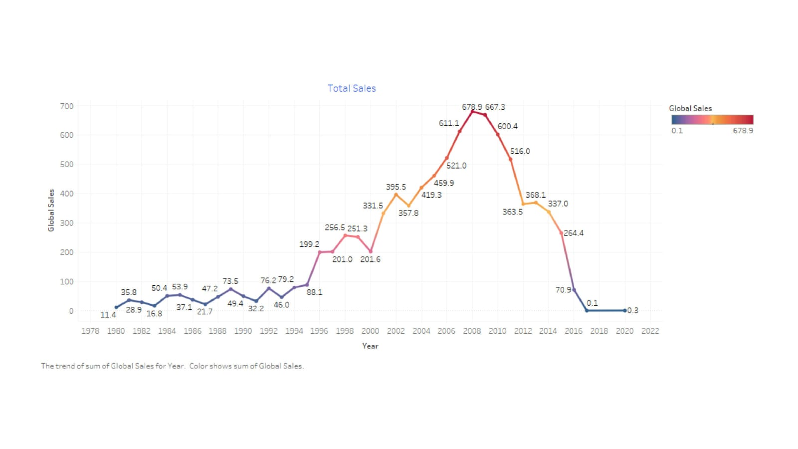

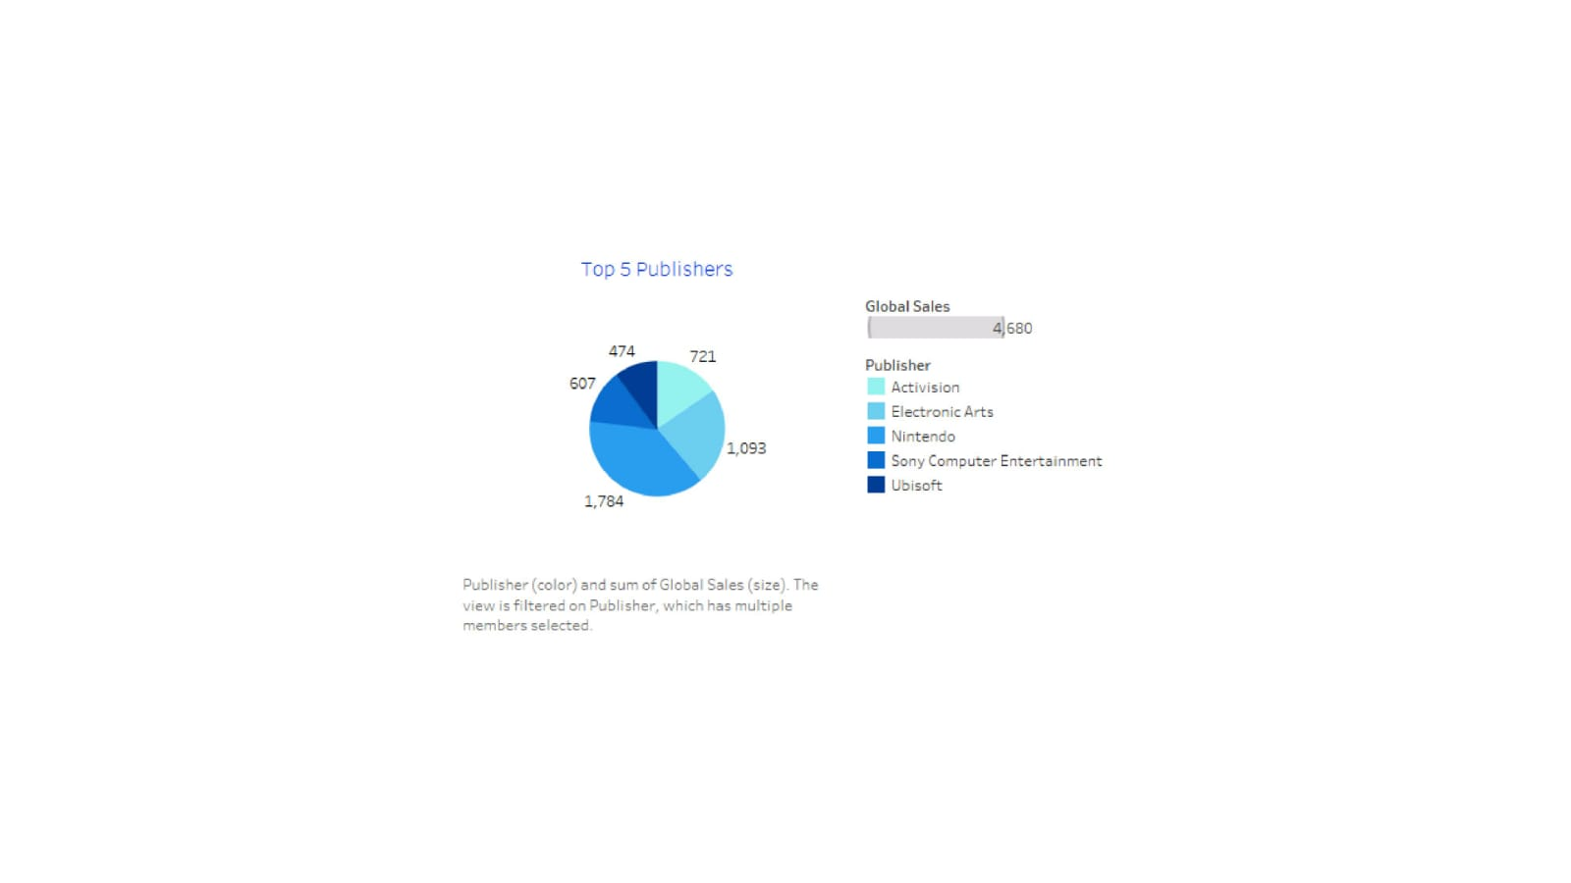

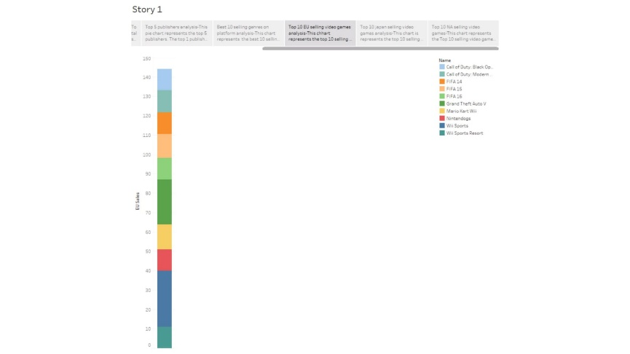

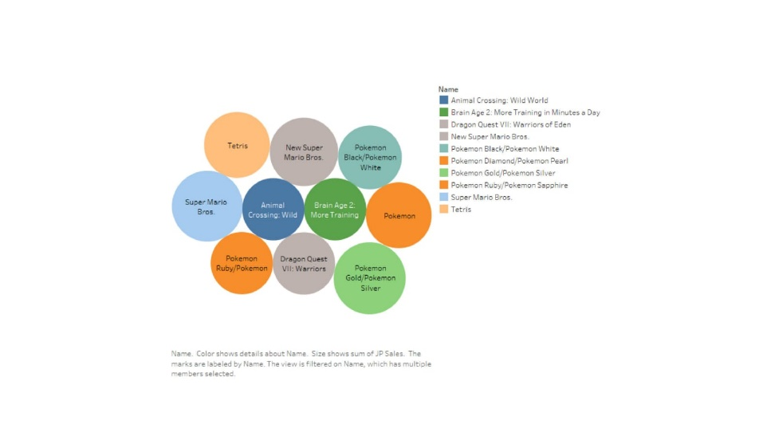

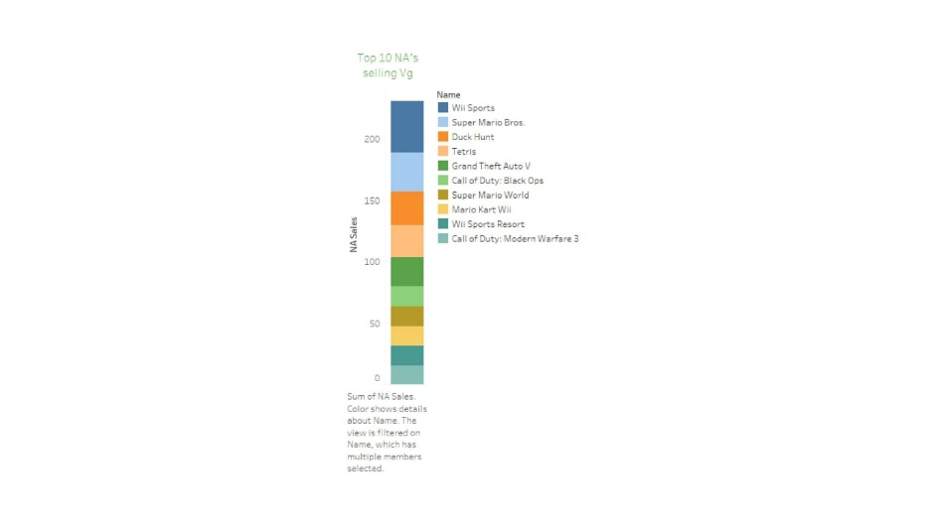

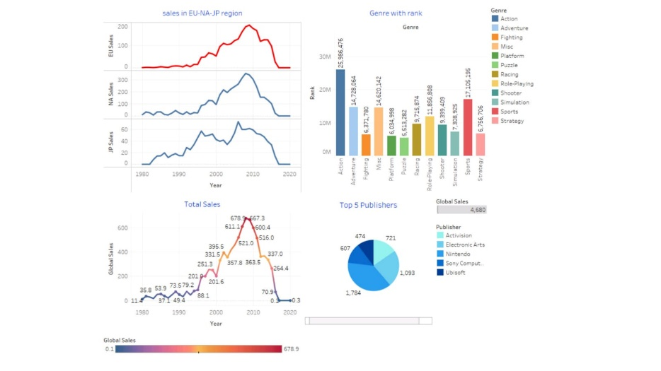

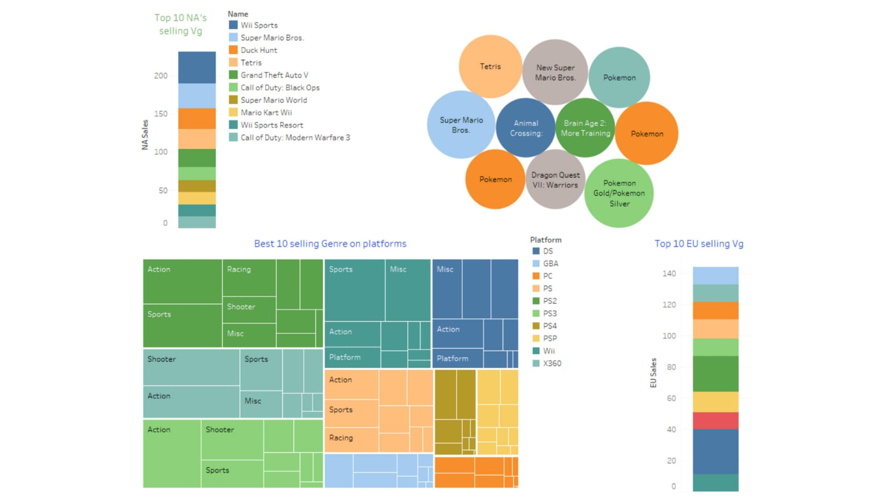

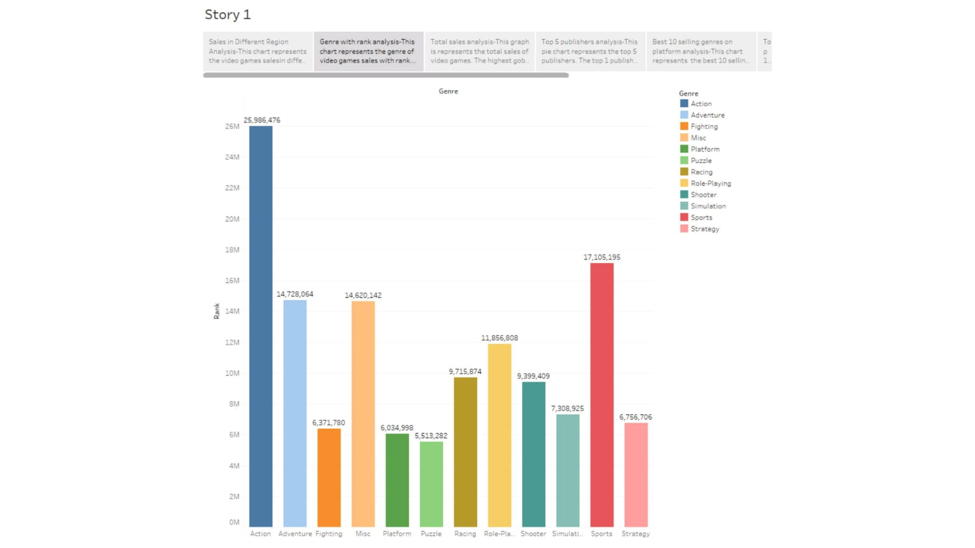

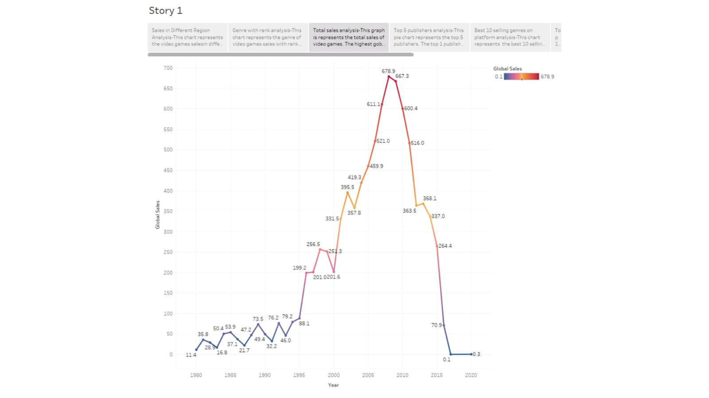

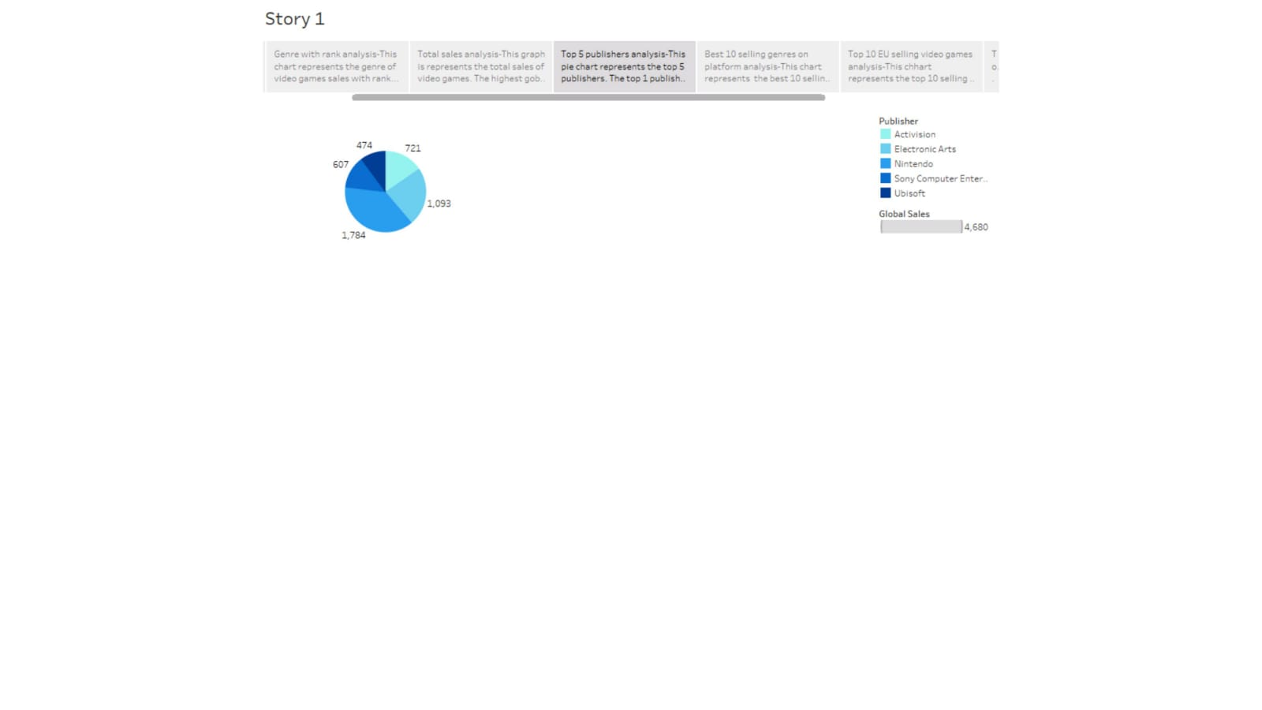

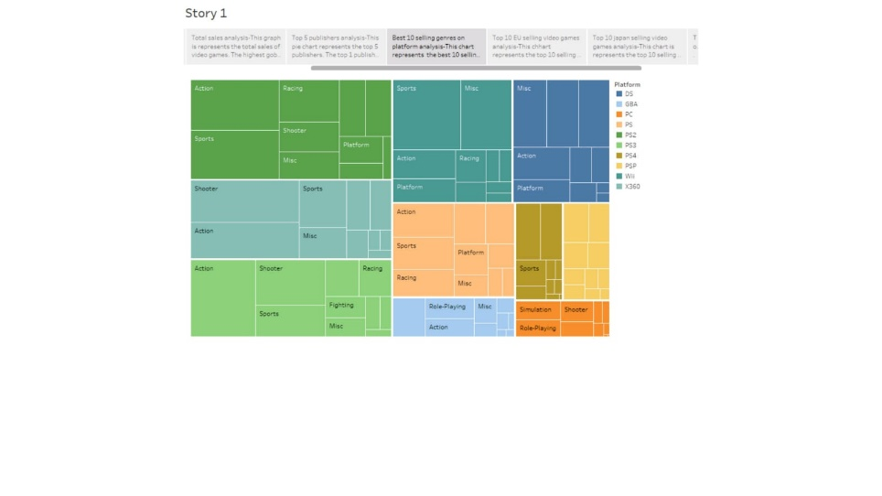

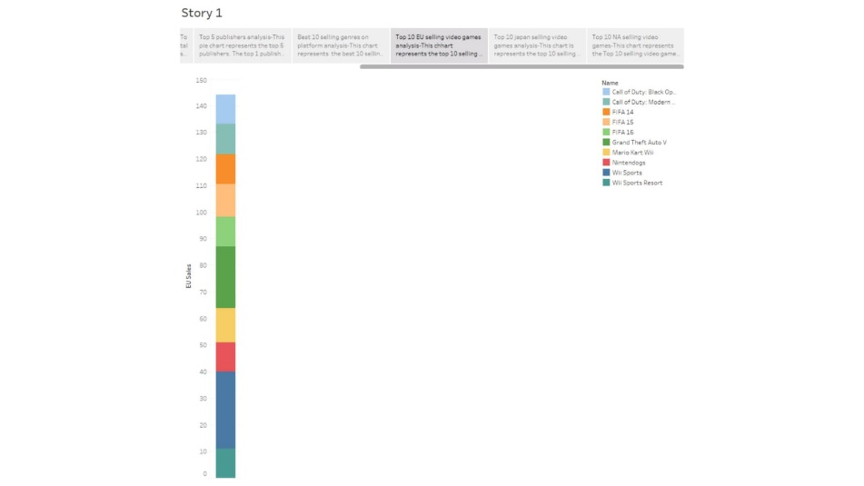

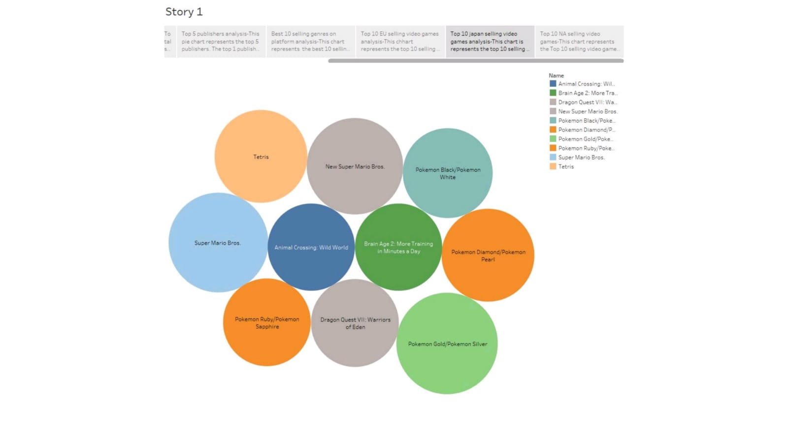

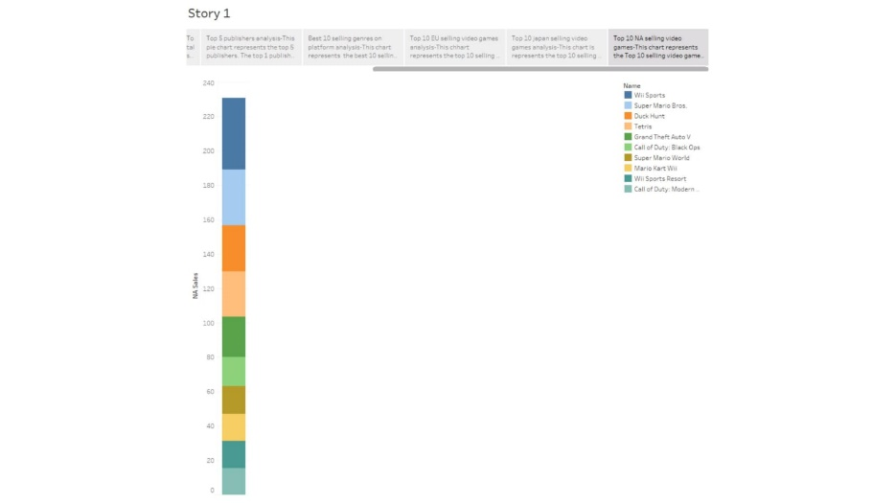

1. **ADVANTAGES & DISADVANTAGES :**

**Advantage: Entertaining and Attention-Grabbing**

Internet users are consuming more video content than ever before. For many people, watching a video is preferable to reading a blog post or consuming other types of content.

**High Engagement and Conversion Rates**

Adding a video, or in some situations, even just the word "video", increases conversion rates staggeringly. Video content gets the highest levels of engagement compared to other types of posts.

**Limitless Creative Potential**

The video format allows for businesses to convey so much information to the viewer, with complete flexibility of style, tone, and message.

**Disadvantages: Time-Consuming Production**

It will take longer to plan and produce a video than it would to deliver other types of marketing content. Video production has to go through several stages before it's complete, which means results can take longer for companies that handle video production in-house.

**Costly Overhead**

Buying or renting video equipment can be expensive, and there are costs to consider beyond the day of shooting, such as scriptwriting and hiring the cast.

1. **APPLICATIONS:**

Entertainment and relaxation, but they can also be used for competitions and for computer learning. Some video games are designed to help improve fine motor skills and hand-eye coordination.

1. **CONCLUSION :**

This paper focuses on cleaning, descriptive analysis, data analysis of related contents and data visualization of the video game dataset to derive the corresponding business application strategies for different groups in the market. The results show that platforms can prioritize the purchase of games in the 'Action' genre and need to focus more on game distribution quality than quantity; publishers should choose platforms and game genres with high sales to sell and invent; users should focus on platforms with high sales and experience to choose a certain type of game product. This study can stimulate game marketing and economy and bring the market into a virtuous cycle. Although this paper uses K-Means algorithm to divide the sales of video game products, it does not dig deeper and analyze the products in each division, and more commonality of products under each division can be explored for improving and proposing better business strategies. The video game market will have broader sales prospects and is worth promoting and propagating vigorously.

1. **FUTURE SCOPE :**

Game Designing is one of the most upcoming Courses for students who wanted to make a Game Designer Career in India in animation. The gaming industry is rapidly growing at a pace of 50% per annum. There is a very wide and bright future in game design in India. Students can earn up to 3 Lakh to 5 Lakh.